SEC Form 3
FORM 3 | UNITED STATES SECURITIES AND EXCHANGE COMMISSION  Washington, D.C. 20549  INITIAL STATEMENT OF BENEFICIAL OWNERSHIP OF SECURITIES  Filed pursuant to Section 16(a) of the Securities Exchange Act of 1934  or Section 30(h) of the Investment Company Act of 1940
  OMB APPROVAL
  OMB Number: | 3235-0104
  Estimated average burden
  hours per response: | 0.5
1. Name and Address of Reporting Person*  (Street) | 2. Date of Event Requiring Statement (Month/Day/Year)  08/05/2026 | 3. Issuer Name and Ticker or Trading Symbol  People Inc [ PPLI ]  Foreign Trading Symbol
  Vogel Neil
  (Last) | (First) | (Middle)
  C/O PEOPLE INCORPORATED
  555 WEST 18TH STREET
  NEW YORK | NY | 10011
  (City) | (State) | (Zip)
 |  | 4. Relationship of Reporting Person(s) to Issuer  (Check all applicable) | 5. If Amendment, Date of Original Filed (Month/Day/Year)
   | Director |  | 10% Owner
   | Officer (give title below) |  | Other (specify below)
  Chief Executive Officer
6. Individual or Joint/Group Filing (Check Applicable Line)
Form filed by One Reporting Person
Form filed by More than One Reporting Person

Table I - Non-Derivative Securities Beneficially Owned
1. Title of Security (Instr. 4) | 2. Amount of Securities Beneficially Owned (Instr. 4) | 3. Ownership Form: Direct (D) or Indirect (I) (Instr. 5) | 4. Nature of Indirect Beneficial Ownership (Instr. 5)
Common Stock, par value $0.0001 | 9,941 | D
Table II - Derivative Securities Beneficially Owned
(e.g., puts, calls, warrants, options, convertible securities)
1. Title of Derivative Security (Instr. 4) | 2. Date Exercisable and Expiration Date (Month/Day/Year) |  | 3. Title and Amount of Securities Underlying Derivative Security (Instr. 4) |  | 4. Conversion or Exercise Price of Derivative Security | 5. Ownership Form: Direct (D) or Indirect (I) (Instr. 5) | 6. Nature of Indirect Beneficial Ownership (Instr. 5)
1. Title of Derivative Security (Instr. 4) | Date Exercisable | Expiration Date | Title | Amount or Number of Shares | 4. Conversion or Exercise Price of Derivative Security | 5. Ownership Form: Direct (D) or Indirect (I) (Instr. 5) | 6. Nature of Indirect Beneficial Ownership (Instr. 5)
Restricted Stock Units | (1) | (1) | Common Stock, par value $0.0001 | 80,377 | (2) | D
Restricted Stock Units | (3) | (3) | Common Stock, par value $0.0001 | 149,434 | (2) | D
Restricted Stock Units | (4) | (4) | Common Stock, par value $0.0001 | 163,908 | (2) | D
Restricted Stock Units | (5) | (5) | Common Stock, par value $0.0001 | 24,592 | (2) | D
Explanation of Responses:
1. Represents restricted stock units ("RSUs") that vest in two installments on each of March 1, 2027 and 2028, subject to continued service.
2. Each RSU represents a contingent right to receive one share of Issuer common stock.
3. Represents RSUs that vest in three equal installments on each of February 4, 2027, 2028 and 2029, subject to continued service.
4. Represents RSUs that vest in one lump sum installment on March 1, 2027, subject to continued service.
5. Represents RSUs that vest in two equal installments on each of March 1, 2027 and 2028, subject to continued service.
Remarks:
Exhibit 24 - Power of Attorney
 | /s/ Jennifer Bishop as Attorney-in-Fact for Neil Vogel | 08/17/2026
 | ** Signature of Reporting Person | Date
Reminder: Report on a separate line for each class of securities beneficially owned directly or indirectly.
* If the form is filed by more than one reporting person, see Instruction 5 (b)(v).
** Intentional misstatements or omissions of facts constitute Federal Criminal Violations See 18 U.S.C. 1001 and 15 U.S.C. 78ff(a).
Note: File three copies of this Form, one of which must be manually signed. If space is insufficient, see Instruction 6 for procedure.
Persons who respond to the collection of information contained in this form are not required to respond unless the form displays a currently valid OMB Number.
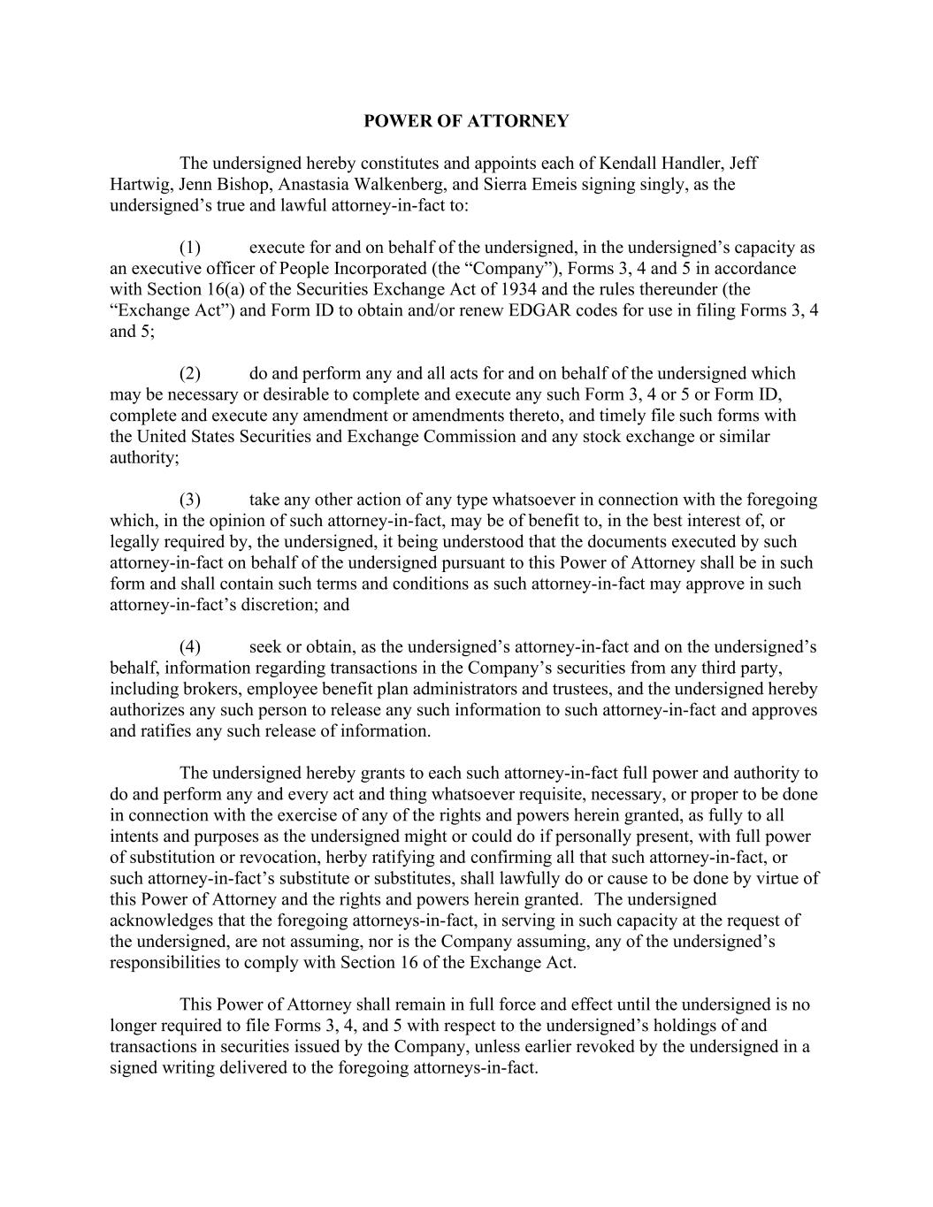
POWER OF ATTORNEY The undersigned hereby constitutes and appoints each of Kendall Handler, Jeff Hartwig, Jenn Bishop, Anastasia Walkenberg, and Sierra Emeis signing singly, as the undersigned’s true and lawful attorney-in-fact to: (1) execute for and on behalf of the undersigned, in the undersigned’s capacity as an executive officer of People Incorporated (the “Company”), Forms 3, 4 and 5 in accordance with Section 16(a) of the Securities Exchange Act of 1934 and the rules thereunder (the “Exchange Act”) and Form ID to obtain and/or renew EDGAR codes for use in filing Forms 3, 4 and 5; (2) do and perform any and all acts for and on behalf of the undersigned which may be necessary or desirable to complete and execute any such Form 3, 4 or 5 or Form ID, complete and execute any amendment or amendments thereto, and timely file such forms with the United States Securities and Exchange Commission and any stock exchange or similar authority; (3) take any other action of any type whatsoever in connection with the foregoing which, in the opinion of such attorney-in-fact, may be of benefit to, in the best interest of, or legally required by, the undersigned, it being understood that the documents executed by such attorney-in-fact on behalf of the undersigned pursuant to this Power of Attorney shall be in such form and shall contain such terms and conditions as such attorney-in-fact may approve in such attorney-in-fact’s discretion; and (4) seek or obtain, as the undersigned’s attorney-in-fact and on the undersigned’s behalf, information regarding transactions in the Company’s securities from any third party, including brokers, employee benefit plan administrators and trustees, and the undersigned hereby authorizes any such person to release any such information to such attorney-in-fact and approves and ratifies any such release of information. The undersigned hereby grants to each such attorney-in-fact full power and authority to do and perform any and every act and thing whatsoever requisite, necessary, or proper to be done in connection with the exercise of any of the rights and powers herein granted, as fully to all intents and purposes as the undersigned might or could do if personally present, with full power of substitution or revocation, herby ratifying and confirming all that such attorney-in-fact, or such attorney-in-fact’s substitute or substitutes, shall lawfully do or cause to be done by virtue of this Power of Attorney and the rights and powers herein granted. The undersigned acknowledges that the foregoing attorneys-in-fact, in serving in such capacity at the request of the undersigned, are not assuming, nor is the Company assuming, any of the undersigned’s responsibilities to comply with Section 16 of the Exchange Act. This Power of Attorney shall remain in full force and effect until the undersigned is no longer required to file Forms 3, 4, and 5 with respect to the undersigned’s holdings of and transactions in securities issued by the Company, unless earlier revoked by the undersigned in a signed writing delivered to the foregoing attorneys-in-fact.

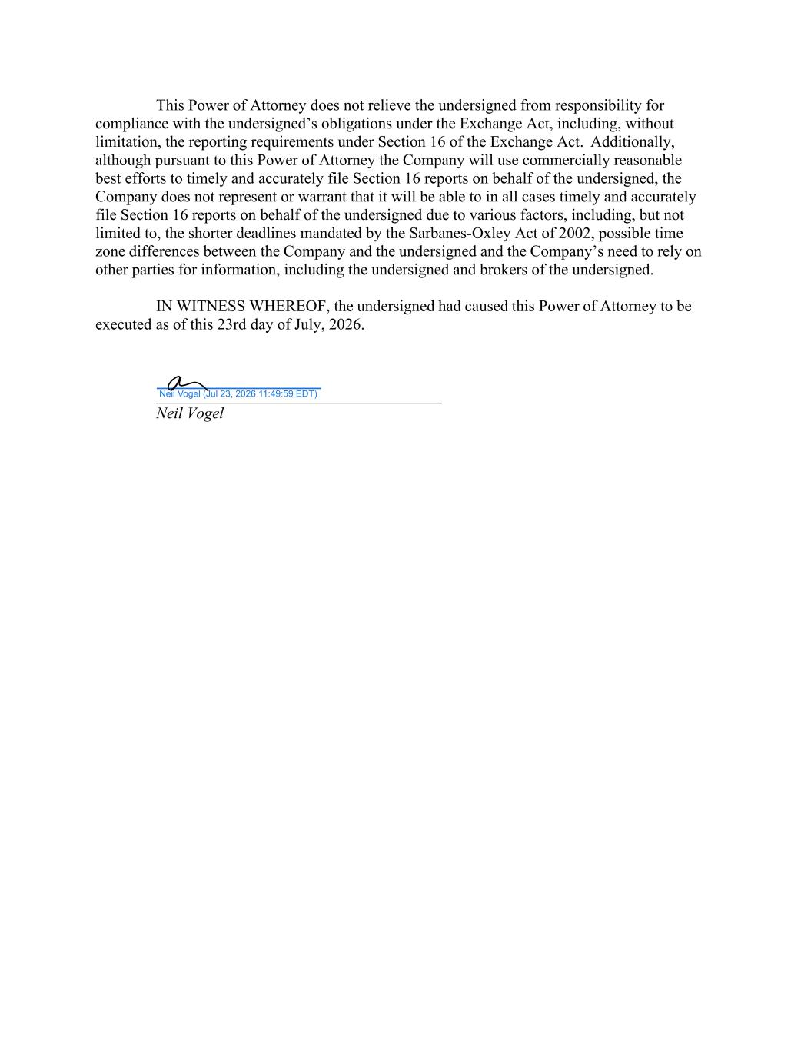
This Power of Attorney does not relieve the undersigned from responsibility for compliance with the undersigned’s obligations under the Exchange Act, including, without limitation, the reporting requirements under Section 16 of the Exchange Act. Additionally, although pursuant to this Power of Attorney the Company will use commercially reasonable best efforts to timely and accurately file Section 16 reports on behalf of the undersigned, the Company does not represent or warrant that it will be able to in all cases timely and accurately file Section 16 reports on behalf of the undersigned due to various factors, including, but not limited to, the shorter deadlines mandated by the Sarbanes-Oxley Act of 2002, possible time zone differences between the Company and the undersigned and the Company’s need to rely on other parties for information, including the undersigned and brokers of the undersigned. IN WITNESS WHEREOF, the undersigned had caused this Power of Attorney to be executed as of this 23rd day of July, 2026. Neil Vogel Neil Vogel (Jul 23, 2026 11:49:59 EDT)

